**Project Design Phase-1 Solution Architecture**

|  |  |
| --- | --- |
| **Date** | **19 November 2022** |
| **Team ID** | **PNT2022TMID05601** |
| **Project Name** | **IOT Based Smart Crop Protection System for Agriculture** |
| **Maximum Marks** | **4 Marks** |

# 

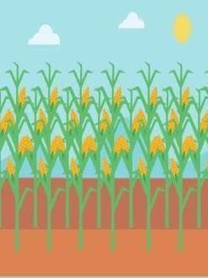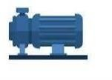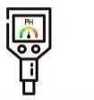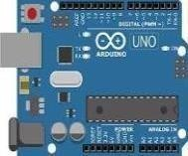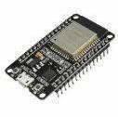

**Camera module**

**Temperature sensor**

**Flame sensor**

**Arduino Micro Gate way**

**PH level sensor controller** **module**

**Cellular tower**

**Internet Cloud**

**Router**

**Water and Now I can monitor my**

**moisture level farm from anywhere at**

**sensor** **anytime**

**Motor Pump**